DO NOT STAPLE

2018 Student Application
Camp Tecumseh – Brookston, Indiana • June 6-9, 2018

NORTHEASTERN REMC
4901 E. Park 30 Drive, Columbia City, IN 46725
ATTN: Michael DeFreeuw

Applications are due at Northeastern REMC no later than February 23, 2018
Students must currently be completing sixth grade in the spring of 2018 to be eligible.

Touchstone Energy® Camp requires physical fitness and stamina, and is not designed for children who need significant assistance for personal care, require constant one-on-one support, or have great difficulty managing their behavior in group settings. If your child has a special health care need, contact your electric cooperative. Health conditions requiring advance clearance include, but are not limited to: insulin dependent diabetes, cardiac situations, asthma, seizure disorders, mental illness, autism spectrum, and serious food allergies.
Last Name: |  |  |  |  |  | First Name: |  |  |  |  |  | Nickname: |  |  |  |  |  | Male Female
Date of Birth : |  | / / |  |  |  | Primary Parent/Guardian cell phone: |  |  |  |  |  |  | ( )
Mailing address: |  |  |  |  |  |  |  |  |  | City: |  |  |  |  |  | State: |  | IN | ZIP:
Parent’s/Guardian’s name(s):
Daytime phone: |  |  | ( ) - |  |  |  |  |  | Email address:
Name of school where student is currently attending sixth grade:
Address of school: |  |  |  |  |  |  |  |  |  |  |  |  |  |  |  | City:
Does your child volunteer in your community? Yes No
Please explain and provide examples:
Does your household receive electricity from a rural electric cooperative (REC/REMC)? Yes No
If yes, what is the name of the REC/REMC?
Does child have any dietary restrictions or special needs the camp staff should be aware of? Please explain:

I am aware that my child is applying for a camp sponsorship opportunity. Failure to provide a cancellation notice (minimum of 30 days) could result in a participant’s parents or guardians being billed for all or a portion of the camp expense. I also understand that photos and/or videos may be taken of camp participants during camp activities. Images could be used for future promotional materials and/or as public information in your local newspaper.
If you DO NOT want your child to appear in these images please submit your request in writing along with this application.

I have read and understand the above statements and assure camp administrators that my son/daughter meets the health requirements as noted and is eligible to participate in Touchstone Energy® Camp, if selected.

^{Parent/Guardian signature} |  |  | ^{DatE}
DO NOT STAPLE

- Touchstone Energy® Brand
- Electric Distribution
- Electrification
- Electrical Safety
- Horseback Riding
- Swimming
- Rock Wall Climbing
- Canoeing
- Archery
- Bucket Truck Rides
- Games

Essay
To select students to attend camp, please have student write a brief essay below.
The judging and selection process is the responsibility of the sponsoring electric cooperative.

Student’s Name ______________________________________________________

Why I want to go to Touchstone Energy Camp:

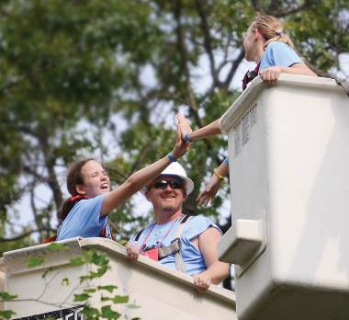

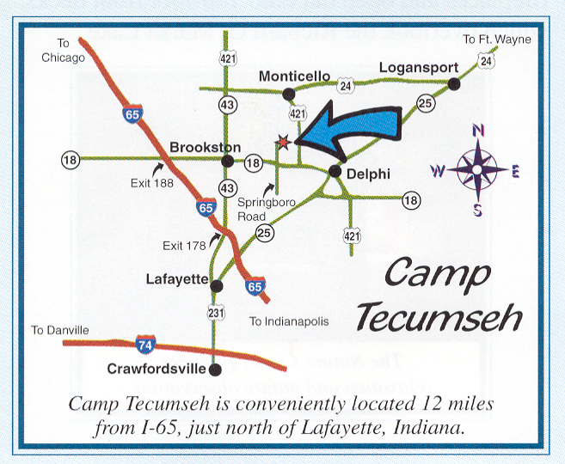
What is Touchstone Energy Camp?

A fun, powerful, and unique camp experience designed for Indiana
students entering seventh grade in 2018.

Imagine starting your child’s summer vacation with cool activities, games, and making new friends! They will also learn about electricity. Most of all they will have lots of fun! It’s an electrifying camp they will never forget!

